**MLCan interface user guide**

This document is desired to instruct user basic steps to use MLCan model through the MATLAB interface. An example for Miscanthus (C4) is presented. (Remember to install image processing package to use “imshow” function for viewing icon and picture in this interface).

1. Copy the “MLCan interface” Folder to your hard disk.
2. There are two ways to run this interface model:

* In MATLAB program: Right click on “main_MLCan.m”; select run file.
* In MATLAB command window: Type “guide”; select “Open Existing GUI”, browse to the “MLCan interface”, select “main_MLCan”, and click on the green triangle icon to run the model.

After this step, user will see the main interface as shown in Figure 1.

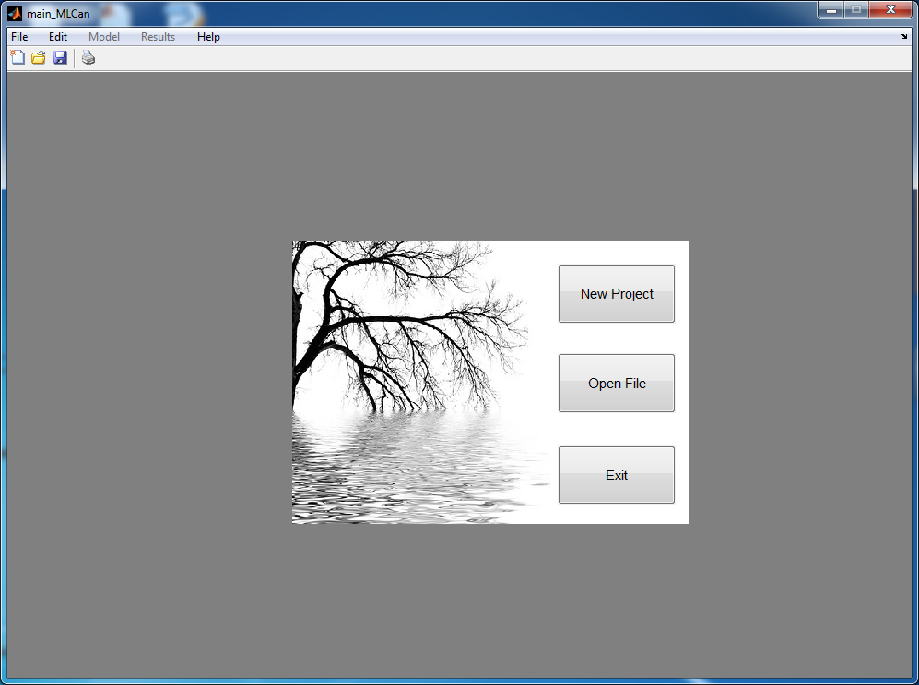

**Figure 1. MLCan main starting interface.**

1. Choose “New Project”, a browsing window will be appeared. In this window, choose “MISCANTHUS_Project”, for example. This project will be saved as “MISCANTHUS_Project.mat”. Then, the main screen will be similar as Figure 2 shown below.

(However, user can load the MISCANTHUS_PROJECT file in MISCANTHUS folder. This example file includes all of information showed in this instruction).

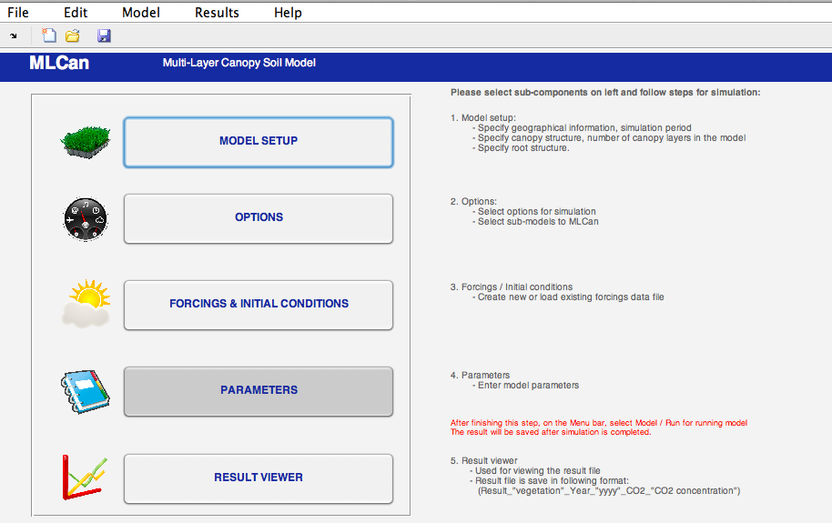

**Figure 2. MLCan working interface.**

1. There are 5 buttons and 5 menu panels to control the model. To set up and enter information for model, click on “SETUP MODEL” or on the menu bar, select “Model / Setup Model”.
2. The screen in Figure 3 should be appeared. This window allows users to enter Site information, Canopy Structure, and Root Structure.

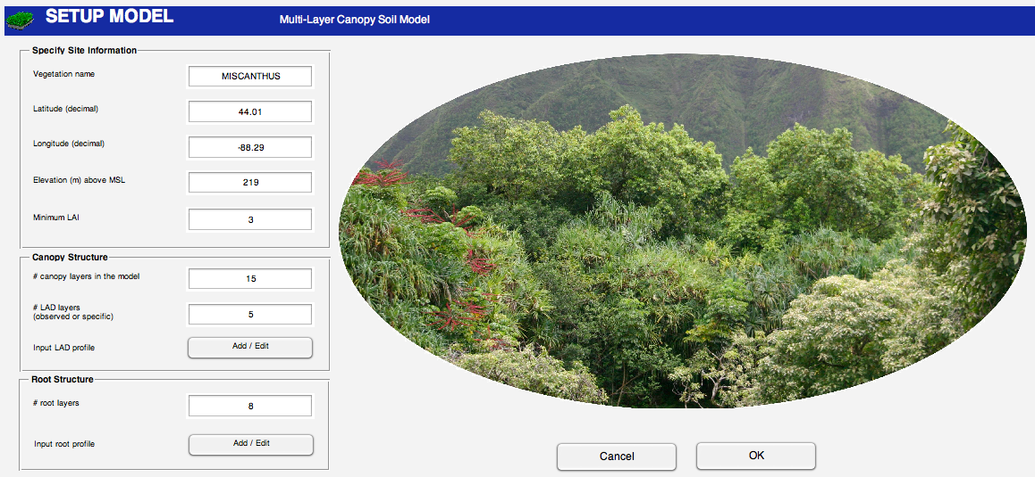

**Figure 3. Model setup interface**

1. Please enter the above information to the boxes in the windows *(Note that geographic locations (lat, long) are used to calculate the ZEN).* There are 2 ways to enter LAD and root profile:

* Using observed data: A table will be provided to import or enter information.
* For Root profile, Jackson equation can be used.

1. Enter number 5 in “# LAD layer box”. The reason for choosing 5 in this example is that there are 5 rows in the Excel file which will be used to import to our model later. Click on “Add / Edit” in the Canopy structure Panel. The following screen will be appeared as shown in Figure 4 (without plot).

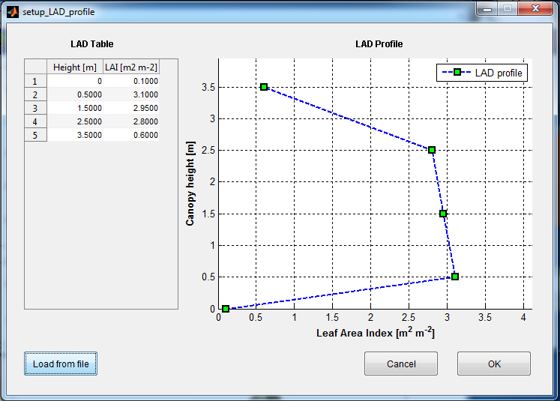

**Figure 4. LAD profile table**

1. User can type numbers or import from Excel file in this window. Click on “Load from file”, select Folder MISCANTHUS, and choose “LAD_Profile.xlsx”. The Plot on the right represents numbers in the table on the left. Moreover, user can also choose another number of LAD layer and enter other profiles. Click “OK“ to go back to the Model Setup*. (Note: the number of layer must be chosen equally to the number of row of data in Excel file).*
2. Similarly, enter number 8 in the “# root layer” box. In this example, choose “Observed Data” option to enter or import data manually. The Setup Root Profile Information screen should be similar to the Figure 5 below. Click on “Load from file” to import data from excel file. Choose “MISCANTHUS / Root_profile.xlsx” file. Click “OK” to go back to the Model Setup.

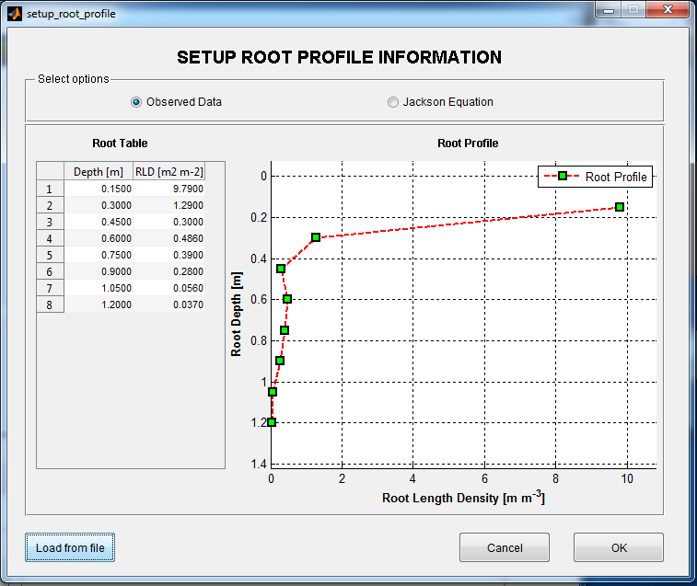

**Figure 5. Root profile table**

1. Click on “OK” in the Model Setup to go back to the main screen, and choose “Save” or “Save as” in File menu to save the project.
2. Click on “OPTIONS” or in menu bar, choose Model/Option. The following screen will be appeared.

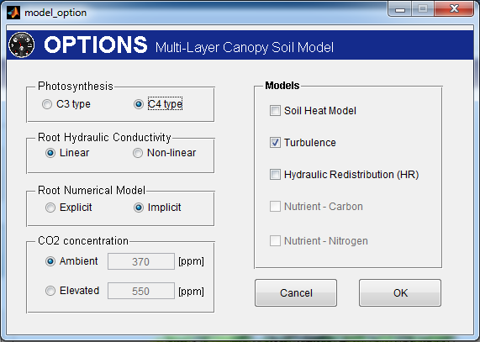

**Figure 6. Model options**

1. Choose options as shown in Figure 6. Click on “OK” to go back to main screen. Remember to save the project.
2. Click on “FORCINGS/CONDITIONS” or on the menu bar, select “Forcings / Initial Conditions”. The following windows will appear:

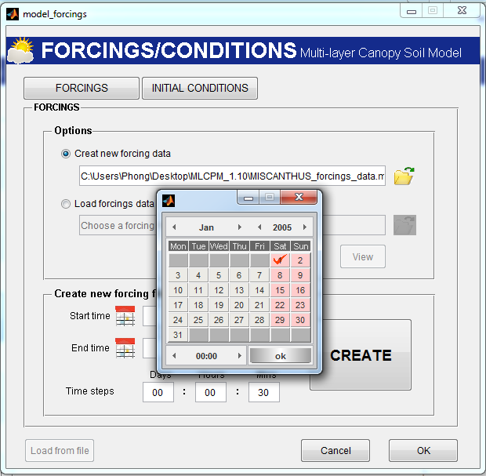

**Figure 7. Forcings and initial condition**

1. There are 2 tabs on this windows, the first one is “FORCINGS” as shown above. This window allows users to create new forcing data file or load existing forcing data file.

* To create new data file: Choose “Create new forcing data” option; click on open folder icon to choose the data file name; click on “Save”. Click on 2 calendar icons in the lower part to choose time and time step. *(The model will automatically calculate the number of time step and other fundamental information. However, please remember to choose time step that can be divided by the simulation time interval).*
* To load a file: Click on open folder icon, choose the forcing data file

Choose start time: Jan, 01, 2005-00:00; end time: Dec 31, 2006-23:30. Click on “CREATE”. Then open Matlab window command to edit or copy and paste information to this file. This file was already created, user can choose “Load forcing data file”, click on open folder icon, select “MISCANTHUS_forcing” file.

1. The second tab is “Initial Condition”. Click on Initial condition tab to enter initial condition for root structure, the number of row in this table will be created equally to the one in model setup step. In the Option window, we did not choose “Soil Heat” model, therefore, Soil temperature column is disable in this windows. Please choose 0.3 for all rows in Soil Moisture column as shown below.

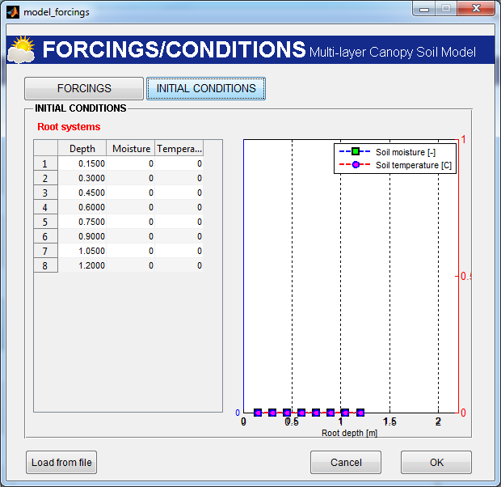

**Figure 8. Initial condition for root**

1. Click on “OK” to go back to the main screen. Remember to save the project.
2. Click on “PARAMETERS”. The screen as shown in Figure 9 will be appeared. Enter values of parameters at each tab (Choose default value for convenient). Click on OK to finish entering information. Remember to save your project.

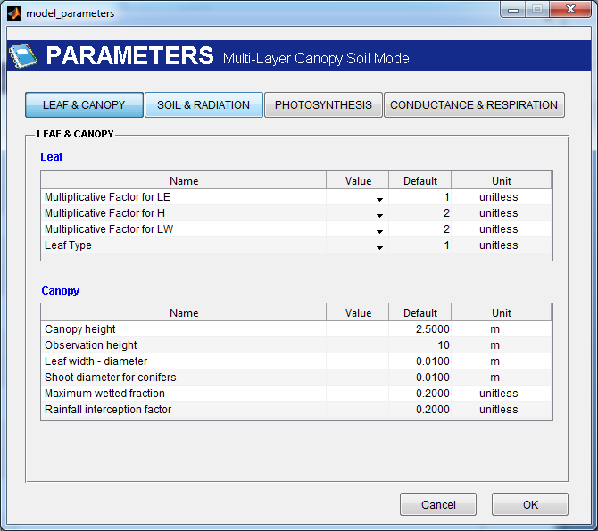

**Figure 9. Initial condition for root**

1. On menu bar, click on Model / Run. The interface will connect with the MLCan and run the model. Wait until the simulation is finished.

The result will be save in the following format: {“Result_” & cropname & year & CO2concentration. mat}

1. After simulation is completed, click on Result to view the results. Click on open icon folder, select the result file (Result_MISCANTHUS_Year_2005_2006_CO2_370.mat)
2. Select result and click on plot to view the result.